Advance Operating System Project-1

A Distributed Shopping System  
Priyanka Kumari

2097792

1. Objective

The objective of create first programming project is to learn Inter-process communication through TCP iterative client, TCP concurrent middle-server, and UDP iterative client-server interaction using socket interface in Java programming language.

2. Project Specification

In this programming project, I implement a distributed group-based shopping system involving TCP protocols in Java language. The sender who is client/user stabilize server and client connection with the middle-server and verify login credentials along with current member credit point to the TCP-Group server. The sender process takes user-entered "TCP-Group server" IP and port from using keyboard.

Following the TCP-Group server Diagram.  
  
  
  
Detail specifications:

* You have to use (10000 + last 4 digits of your student-id number) to avoid requesting same port by multiple students. Group server gets middle server port number + 1.
* Your middle server process is responsible for verifying the user authentication and the group server details based on points.
* userList.txt

3. Programming Notes:

1. Sender: KumariP1Sender.java
2. MidServer: KumariP1MidServer.java
3. GroupServer: KumariP1SeverSilver.java, KumariP1SeverGold.java, and KumariP1SeverPlatinum.java
4. Other Files:
   1. Shopping Price and Detail: silver.txt, gold.txt, platinum.txt
   2. User List Detail: userList.txt
   3. User Login and cost update: FileReplace.java

4. Files

1. Sender: KumariP1Sender.java  
   In this file basically Sender is client.
   1. Using Socket to connect MidServer (i.e Server). IP Address and Port number user input. 
   2. DataOutputStream for sending data from Sender to MidServer.  
      
   3. WriteUTF() write data and Sender to MidServer  
      
   4. DataInputStream for receive data from MidServer to Sender  
      
   5. ReadUTF() for read data from MidServer to Sender and System.out.println () used display data to console.   
      
   6. S.close() for closing port of Socket s.

1. MidServer: KumariP1MidServer.java
   1. Main()
      1. ServerSocket is used to start server and wait for client and serverSocket.accept() update when client is there.  
         Graphical user interface, text

         Description automatically generated
      2. Send data to Sender used DataOutputStream WriteUTF(),
      3. Receive data from Sender used DataInputStream, and ReadUTF()
      4. gerneralSocket() for closing serversocket.
   2. extracted()
      1. Created a java file FileReplace for checking login and update cost **using pointer.**  
         
      2. Verify login credentials, taking user group from FileReplace.  
         MidServer work as client and used socket to connect Silve/Gold/Platinum server. Port used:   
         Silver->10000 + last 4 digits of your student-id number+1

Gold->10000 + last 4 digits of your student-id number+1

Platinum->10000 + last 4 digits of your student-id number+1

* + 1. Send data to MidServer to GroupServer used DataOutputStream WriteUTF(), and Send data to Sender used DataOutputStream WriteUTF(),
    2. Receive data from GroupServer to MidServer used DataInputStream, and ReadUTF(), and Receive data from Sender used DataInputStream, and ReadUTF()

1. GroupServer:

GroupServer work as the server and connect with the MidServer as a client.

* 1. KumariP1SeverSilver.java
  2. KumariP1SeverGold.java
  3. KumariP1SeverPlatinum.java

Same for all files.

* + 1. File use to know the location of file, FileReader read the file, and bufferReader will read Silve/Gold/Platinum txt file line by line. 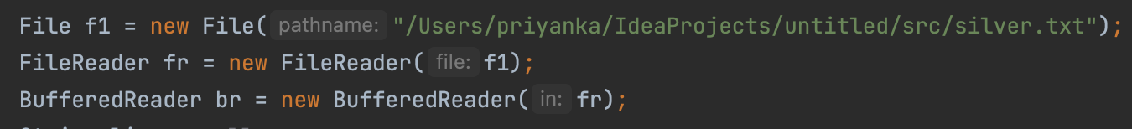
    2. BufferReader will read txt file line by line and split the line by splace to know the shopping product name and id  
       Graphical user interface, application, website

       Description automatically generated
    3. After revice the choice from the Sender. BufferReader will read txt file line by line and split the line by splace to know the shopping product cost and send to midServer.  
       Graphical user interface, text

       Description automatically generated

1. Other Files:
   1. Shopping Price and Detail: silver.txt, gold.txt, platinum.txt
   2. User List Detail: userList.txt
   3. User Login and cost update: FileReplace.java
      1. File use to know the location of file, FileReader read the file, and bufferReader will read UserList.txt file line by line.

Structure:

Result:

